**Learn more about your health** Today, Americans are more health-conscious, more aware of their bodies and considerably more knowledgeable about physical health and wellness.

As part of Gothenburg Health's focus on improving our service area's health and wellness, we're now offering Direct Access Testing (DAT). Individuals can come to the laboratory and receive wellness screenings without a written physician's order. Screenings available through Direct Access Testing allow you to manage your health and health concerns.

**Quick, easy and convenient** Direct Access Testing is not meant as a substitute for regular medical care; it is a quick, easy, and convenient way for people to receive health info.

* A physician's order is not required for these tests.
* 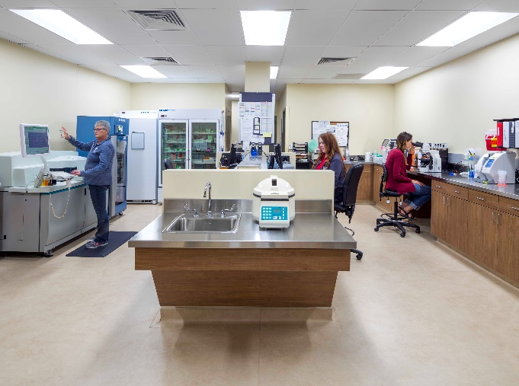The customer, if 18 or older, or par- ent/legal guardian for those under 18, consent to take responsibility for the follow up of abnormal test re- sults.
* Payment in cash or check must be received at the time of service; insur- ance will not be billed.
* The results will be sent directly to you within one week of collecting the specimen. You are encouraged to share the results with your health care provider.

# Direct Access Testing

Direct Access Testing at Gothenburg Health is available without a physician's order in the hospital lab, Monday - Friday from 7 a.m. to 5 p.m.

**Call to Schedule**

Call 308-537-4066 to schedule your screening. Walk-in availability.

**Gothenburg Health**

910 20th Street

Gothenburg, NE 69138

**Phone: 308-537-4066**

**www.gothenburghealth.org**

03.017.2023

**Direct Access Testing**

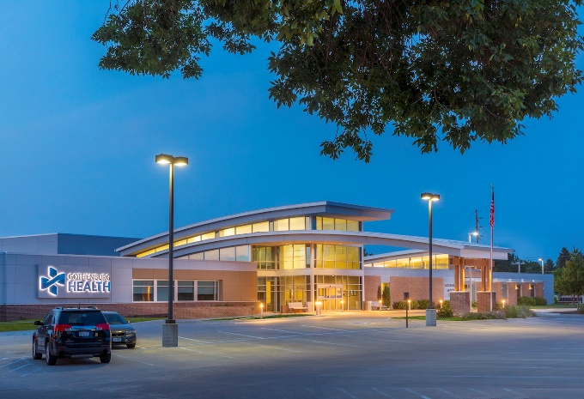Learn more about your health



**Direct Access Testing**

Gothenburg Health Lab

Monday - Friday

## 7 a.m. to 5 p.m.

**Direct Access Testing at Gothenburg Health's Laboratory**



# *Description of direct access tests offered at Gothenburg Health.*

# CBC $15

(Complete blood count) is a blood test used to evaluate your overall health and detect a wide range of disorders.

**Comprehensive $19 Metabolic Panel\***

Screens for diabetes, fluid balance, kidney function and liver function.

* + Electrolytes
  + Glucose
  + BUN
  + Creatinine
  + Calcium
  + Albumin
  + Alkaline Phosphatase
  + ALT/AST
  + Total Bilirubin
  + Total Protein

# COVID-19 $40

Rapid antigen test

# Hemoglobin A1C Wellness $18

[www.gothenburghealth.org](http://www.gothenburghealth.org) | 910 20th St | Gothenburg, NE 69138 | 308-537-4066 |

*Gothenburg Health is an equal opportunity provider and employer*

Glycohemoglobin (Diabetes)

**Lipid Panel* $16**

* + Cholesterol
  + Triglyceride
  + HDL Cholesterol
  + LDL Cholesterol (calc)

**PSA Screen (Prostate) $25** Detects an antigen suspicious for cancer of the prostate. This screening may be recommended for men age 55-69. *Many exceptions may apply based upon your unique medical and family history and other risk factors.It's highly recommended that this test be done in conjunction with an annual provider exam.*

**For more information call 308-537-4066**

**\*Tests listed with an asterisk require fasting.**

**Please follow these guidelines for a successful screening:**

* Fasting for the laboratory means that the individual should consume no solid or liquid food for 12 hours before the test.
* No alcohol 24 hours before specimen collection.
* Water can be taken in normal amounts.
* If taking medication, continue medication as directed by your health provider.

# TSH Wellness $16

TSH (Thyroid)

# Urine Drug Screen $15

A urine drug screen analyzes urine for certain illegal drugs and prescription medication. Specimens must be collected at the lab.

# Vitamin D $58

# Vitamin D deficiency may lead to a range of disorders, such as osteoporosis.